GenevaERS Backup Facility

# Concepts and Facilities

The principle by GvbBackup is to determine which files have changed since the last incremental back-up and select these files to back-up to Box. GvbBackup selects files that have changed within the last ‘n’ days (default value is 1 day). It copies these files to a ‘shadow’ directory structure within Temp/ directory, so that GvbBackup can create a 7Zip archive. A subsequent task copies the archive to Box.

This allows a set of ‘Delta’ saves to be make and zipped copies sent to Box, each with its own unique date|time stamp in the file name.

A ‘Full’ save of all relevant files can be made by specifying zero days. This allows merging of the initial full save with subsequent delta saves to provide all the data that would have been contained within a full save – without ever having to perform another full save.

# Installation

If you are using a procedure other than GvbBackup to select the files to back-up and perform 7 Zip start at step 8) which deals just with Windows Scheduler.

## Create director Temp on your drive C:\

## Copy – or get from IBM Git—the following source files

Store these files in C:\Temp you created

GvbBackup.java

GVBA2I.java

## Compile for the version of Java you have installed

Javac GvbBackup.java

This compiles both sources to create all necessary classes

## Set up 7 Zip on your computer

Needed if not already done.

## Set up Box folder on your computer

Needed if not already done.

## Add C:\Program Files\ to PATH environment variable

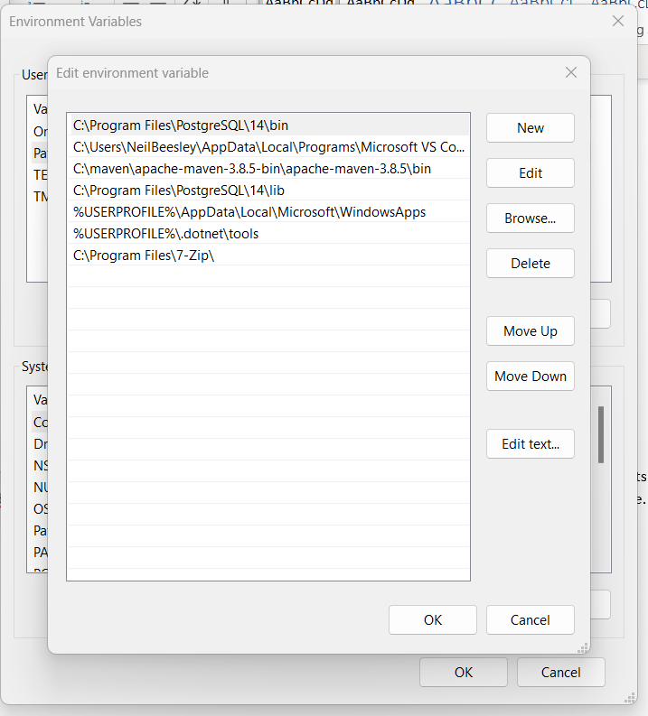

**Append to User Path: C:\Program Files\7-Zip**

## Tailor the GvbBackup configuration file

This file determines the directories and suffixes that are excluded from Delta saves as well as any directories that you might want included for back-up such as Outlook .pst and certain .config files, by overriding the excluded directories with a more specific included path. The included directory path must have more ‘levels’ than the excluded directory path it pertains to.

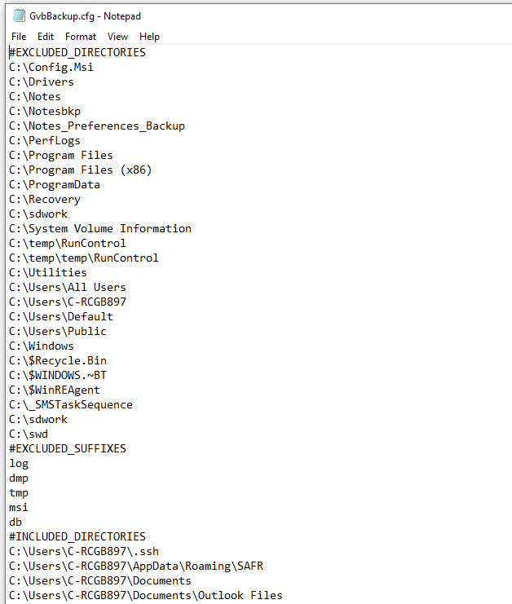

## Set up Windows Scheduler for back-up program GvbBackup

Chose backup frequency, i.e. one day, 3 days, 14 days, etc. Optional command line arguments for GvbBackup are at user’s discretion. GvbBackup -h shows the command line options currently available also, which must batch the back-up periodicity specified here.

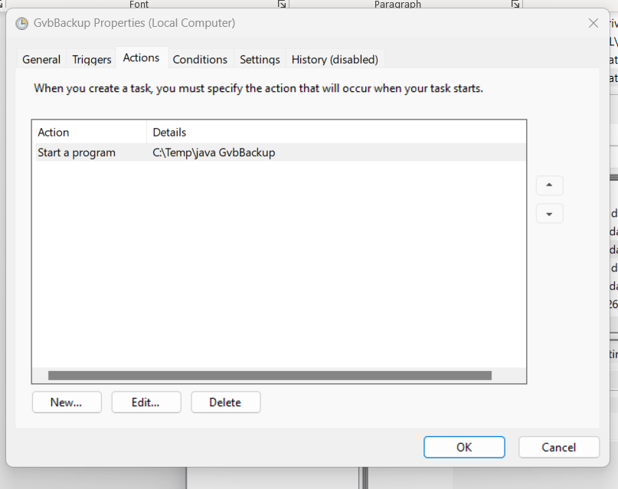

The same action can also run from the command line: java GvbBackup

## Set up Windows Scheduler for copying to Box

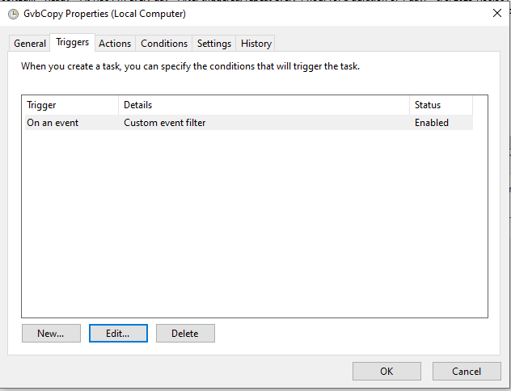

Set up a custom event trigger for this task:

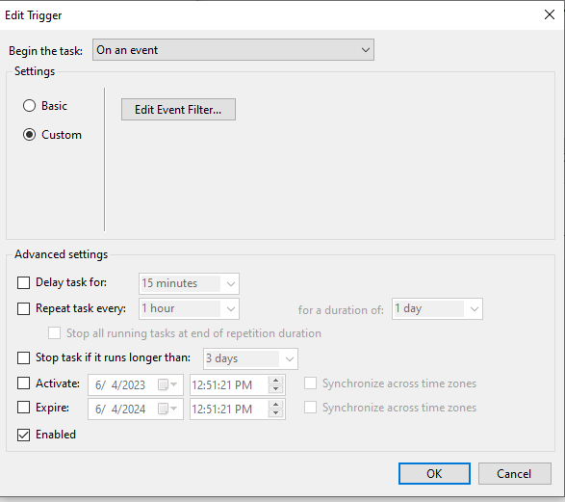

Define filters for custom events using the XML tab

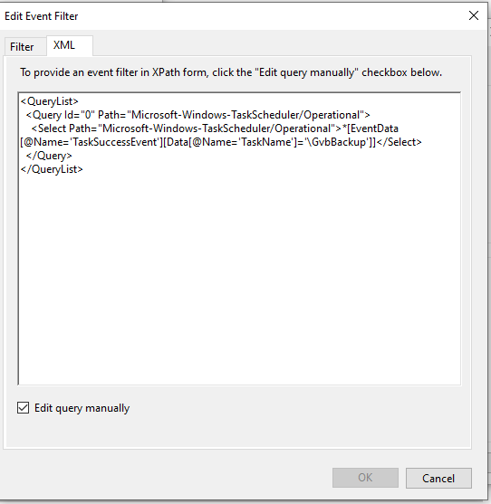

The event causes the specified files to be copied to Box when triggered on completion of the prior task [i.e., ‘TaskSuccessEvent’]. The prior task is GvbBackup when it selected the required files and creating the 7 Zip archive.

In the case of using GvbBackup the program creates a log and a 7Zip file, then created the following .bat file:

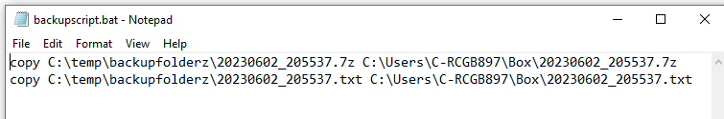

The defined action to run the above .bat file is show below

